Solve these four questions and submit in hand written form. If you have multiple files, zip those into a single file, rename it with your $ID – $NAME format and then upload.

1. For the following table build a decision tree 15

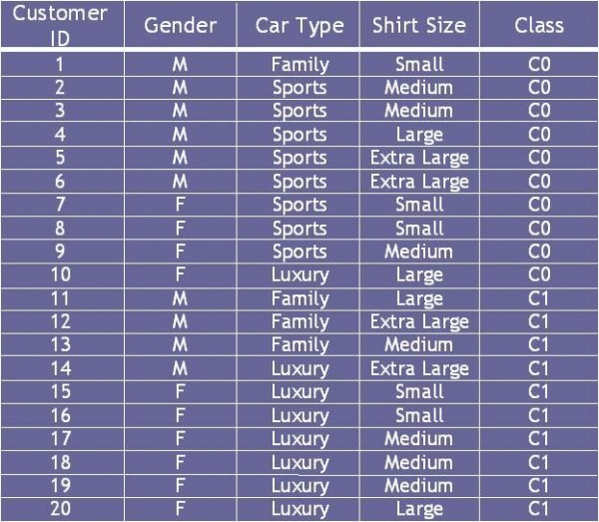

1. For the following table design a neural network with one hidden layer. Then try at least three forward pass and two backward pass while trying to classify the records. You have to use sigmoid function as the activation function. 20

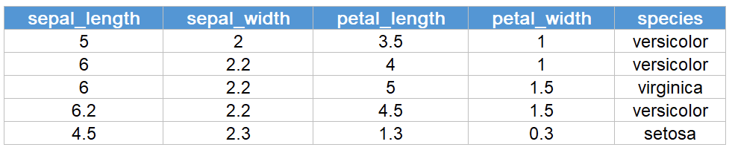

1. For the following confusion matrix calculate the values for precision, recall and F-measure. 5

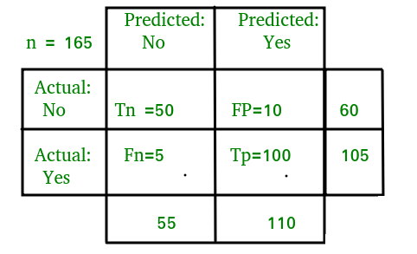

1. Convert the following story info first order knowledge base.

Diana, Marry, George and Alien all are students of CSE440. All of them are assigned final assignments for online evaluation. Not all students copy from his/her peers. Some students copy from peers i.e. they cheat. Those who do not cheat love everybody. Those who cheat love who do not cheat. Diana loves George. George loves Alien. Alien loves Diana. Alien does not love Marry. 10

Using your preferred inference algorithm find whether there is any who cheat? If there is any, find their names. 10